Hi Aaron,

I am writing to give you two points I want to talk about tomorrow.

I. Out of reality, for different time series data, we may need different kinds of state space models, so I hope we can talk about how to find one corresponding state space model given one time series. I already did some reading, the main source is Section 3.4 of Book <time series analysis by state space methods> <https://www.oxfordscholarship.com/view/10.1093/acprof:oso/9780199641178.001.0001/acprof-9780199641178-chapter-3>

For example, how to find that of ‘airline model’ ($ARIAM\left(0,1,1\right)×{\left(0,1,1\right)}_{12}$)? In the report of Durbin, he mentioned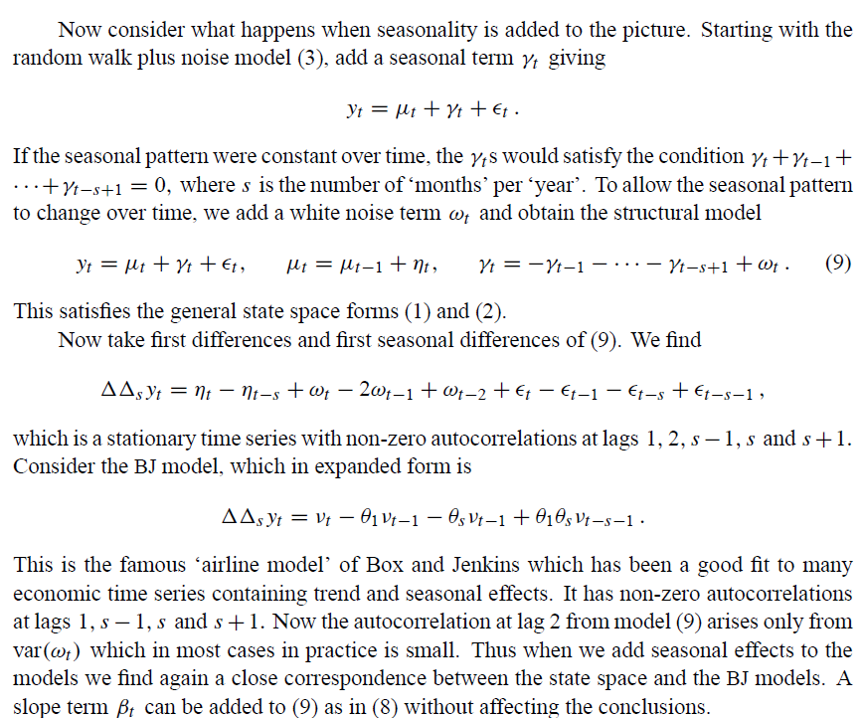

But this model is not accurate(does not reflect coefficients), shall we talk about the specific expression?

II. I am learning some packages(basically is pomp, some with BayesianTools) related to state space methods and could talked about them.